**Lab. Work 4**

**Name: Ravinthiran Partheepan**

**Course: Data mining Methods**

**Submission date: 12/10/2023**

**Problem Statement:**

Part 1:

Ex 1: Show the total sum of Fclass, Bclass, Eclass passengers

EX 2: Print passenger data where destination is = ‘SEA’

EX 3: Print passenger data where destination is = ‘SEA’ suppress observation column

Part 2:

Ex 1: Show personal data where State='NY' and JobCode in ('FA1' 'FA2' 'FA3’)

Ex 2: Show personal data where Last Name has first two characters ‘BR’

**Tasks:**

**Part 1:**

Code Snippet:

libname pass_lib '/home/u63603566/Lab - 4';

/*Total sum of FClass, BClass, EClass passengers */

data total_passengers;

set pass_lib.passngrs;

TotalPassengers = FClass + BClass + EClass;

run;

proc print data=total_passengers;

run;

/*Print passenger data where destination is 'SEA' */

proc print data=pass_lib.passngrs;

where Dest = 'SEA';

run;

/*Print passenger data where destination is 'SEA' and suppress observation column */

proc print data=pass_lib.passngrs noobs;

where Dest = 'SEA';

run;

**Results:**

**1.1 Sum of All passengers in FClass, BClass, and EClass:**

| **Obs** | **FlightID** | **Dest** | **Depart** | **FClass** | **BClass** | **EClass** | **TotalPassengers** |
| --- | --- | --- | --- | --- | --- | --- | --- |
| **1** | IA01802 | SEA | 15101 | 10 | 9 | 132 | 151 |
| **2** | IA01804 | SEA | 15101 | 11 | 12 | 111 | 134 |
| **3** | IA02901 | HNL | 15101 | 13 | 24 | 138 | 175 |
| **4** | IA03100 | ANC | 15101 | 13 | 22 | 150 | 185 |
| **5** | IA03101 | ANC | 15101 | 14 | . | 133 | . |
| **6** | IA01802 | SEA | 15102 | 12 | 11 | 126 | 149 |
| **7** | IA01804 | SEA | 15102 | 12 | 8 | 119 | 139 |
| **8** | IA02901 | HNL | 15102 | 14 | 25 | 132 | 171 |
| **9** | IA03100 | ANC | 15102 | 16 | 26 | 143 | 185 |
| **10** | IA01802 | SEA | 15103 | 12 | 13 | 115 | 140 |
| **11** | IA01804 | SEA | 15103 | 12 | 12 | 136 | 160 |
| **12** | IA02901 | HNL | 15103 | 12 | 21 | 155 | 188 |
| **13** | IA03100 | ANC | 15103 | 14 | 18 | 137 | 169 |
| **14** | IA01802 | SEA | 15104 | 10 | 18 | 128 | 156 |
| **15** | IA01804 | SEA | 15104 | 11 | 17 | 105 | 133 |
| **16** | IA02901 | HNL | 15104 | 13 | 22 | 150 | 185 |
| **17** | IA03100 | ANC | 15104 | 14 | 17 | 144 | 175 |
| **18** | IA03101 | ANC | 15104 | 13 | . | 142 | . |
| **19** | IA01802 | SEA | 15105 | 11 | 14 | 131 | 156 |
| **20** | IA01804 | SEA | 15105 | 11 | 18 | 104 | 133 |
| **21** | IA02901 | HNL | 15105 | 13 | 14 | 145 | 172 |
| **22** | IA03100 | ANC | 15105 | 15 | 22 | 99 | 136 |
| **23** | IA01802 | SEA | 15106 | 12 | 15 | 106 | 133 |
| **24** | IA01804 | SEA | 15106 | 10 | 15 | 111 | 136 |
| **25** | IA02901 | HNL | 15106 | 13 | 24 | 137 | 174 |
| **26** | IA03100 | ANC | 15106 | 15 | 16 | 137 | 168 |
| **27** | IA01802 | SEA | 15107 | 12 | 17 | 131 | 160 |
| **28** | IA01804 | SEA | 15107 | 10 | 13 | 113 | 136 |
| **29** | IA02901 | HNL | 15107 | 13 | 19 | 144 | 176 |
| **30** | IA03100 | ANC | 15107 | 15 | 23 | 105 | 143 |

Table 1: Total Sum of Passengers in each flight

The above table states the total sum of passengers in each flight by summing up all the passenger counts from [BClass, FClass, EClass]. For example, if we take a sample with the flight ID = IA01802, there are 151 passengers boarded the flight.

**1.2 Print passenger data where destination is = ‘SEA’**

| **Obs** | **FlightID** | **Dest** | **Depart** | **FClass** | **BClass** | **EClass** |
| --- | --- | --- | --- | --- | --- | --- |
| **1** | IA01802 | SEA | 15101 | 10 | 9 | 132 |
| **2** | IA01804 | SEA | 15101 | 11 | 12 | 111 |
| **6** | IA01802 | SEA | 15102 | 12 | 11 | 126 |
| **7** | IA01804 | SEA | 15102 | 12 | 8 | 119 |
| **10** | IA01802 | SEA | 15103 | 12 | 13 | 115 |
| **11** | IA01804 | SEA | 15103 | 12 | 12 | 136 |
| **14** | IA01802 | SEA | 15104 | 10 | 18 | 128 |
| **15** | IA01804 | SEA | 15104 | 11 | 17 | 105 |
| **19** | IA01802 | SEA | 15105 | 11 | 14 | 131 |
| **20** | IA01804 | SEA | 15105 | 11 | 18 | 104 |
| **23** | IA01802 | SEA | 15106 | 12 | 15 | 106 |
| **24** | IA01804 | SEA | 15106 | 10 | 15 | 111 |
| **27** | IA01802 | SEA | 15107 | 12 | 17 | 131 |
| **28** | IA01804 | SEA | 15107 | 10 | 13 | 113 |

Table 2: Passengers Travelling only to the destination = “SEA”

The above table lists only the flights travelling to the destination = "SEA" with passengers counts from BClass, FClass, and EClass.

**1.3 Print passenger data where destination is = ‘SEA’ suppress observation column**

| **FlightID** | **Dest** | **Depart** | **FClass** | **BClass** | **EClass** |
| --- | --- | --- | --- | --- | --- |
| IA01802 | SEA | 15101 | 10 | 9 | 132 |
| IA01804 | SEA | 15101 | 11 | 12 | 111 |
| IA01802 | SEA | 15102 | 12 | 11 | 126 |
| IA01804 | SEA | 15102 | 12 | 8 | 119 |
| IA01802 | SEA | 15103 | 12 | 13 | 115 |
| IA01804 | SEA | 15103 | 12 | 12 | 136 |
| IA01802 | SEA | 15104 | 10 | 18 | 128 |
| IA01804 | SEA | 15104 | 11 | 17 | 105 |
| IA01802 | SEA | 15105 | 11 | 14 | 131 |
| IA01804 | SEA | 15105 | 11 | 18 | 104 |
| IA01802 | SEA | 15106 | 12 | 15 | 106 |
| IA01804 | SEA | 15106 | 10 | 15 | 111 |
| IA01802 | SEA | 15107 | 12 | 17 | 131 |
| IA01804 | SEA | 15107 | 10 | 13 | 113 |

Table 3: Passenger Travelling to “SEA” without observation ID

The above table lists only the flights travelling to the destination = "SEA" without the observation feature.

**Part – 2:**

Code Snippet:  
  
libname data '/home/u63603566/Lab - 4';

/* Show personl data where State='NY' and JobCode in ('FA1' 'FA2' 'FA3') */

proc print data=data.personl;

where State = 'NY' and JobCode in ('FA1', 'FA2', 'FA3');

run;

/* Show personl data where Last Name has first two characters 'BR' */

proc print data=data.personl;

where substr(LName, 1, 2) = 'BR';

run;

**Results:**

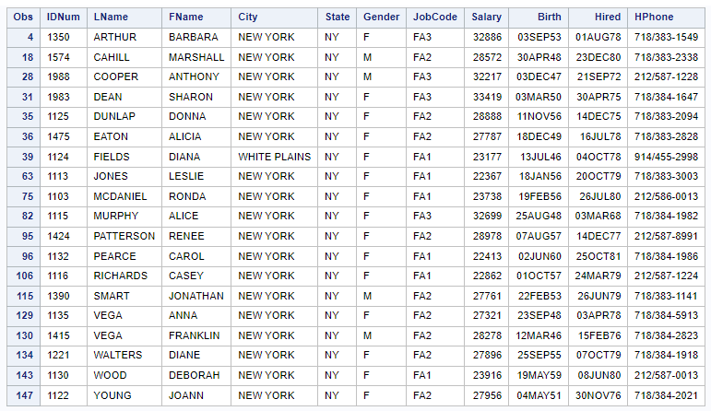

Figure 1: List of persons who’s JOBCODE = [FA1,FA2,FA3], and State “NY”

The above figure displays data related to individuals whose job codes are in the category [FA1, FA2, FA3], and whose state is [NY].

| **Obs** | **IDNum** | **LName** | **FName** | **City** | **State** | **Gender** | **JobCode** | **Salary** | **Birth** | **Hired** | **HPhone** |
| --- | --- | --- | --- | --- | --- | --- | --- | --- | --- | --- | --- |
| **13** | 1658 | BRADLEY | JEREMY | NEW YORK | NY | M | SCP | 17943 | 11APR55 | 03MAR80 | 212/587-3622 |
| **14** | 1428 | BRADY | CHRISTINE | STAMFORD | CT | F | PT1 | 68767 | 07APR58 | 19NOV79 | 203/781-1212 |
| **15** | 1782 | BROWN | JASON | STAMFORD | CT | M | ME2 | 35345 | 07DEC58 | 25FEB80 | 203/781-0019 |
| **16** | 1244 | BRYANT | LEONARD | NEW YORK | NY | M | ME2 | 36925 | 03SEP51 | 20JAN76 | 718/383-3334 |

Table 4: List of persons who’s LNAME starts with "BR"

The above table lists the names of individuals whose names start with the letters [BR].

**Github Repository**: